Project: Market Analysis Report for National Clothing Chain

Power Query

Resulting Data Model

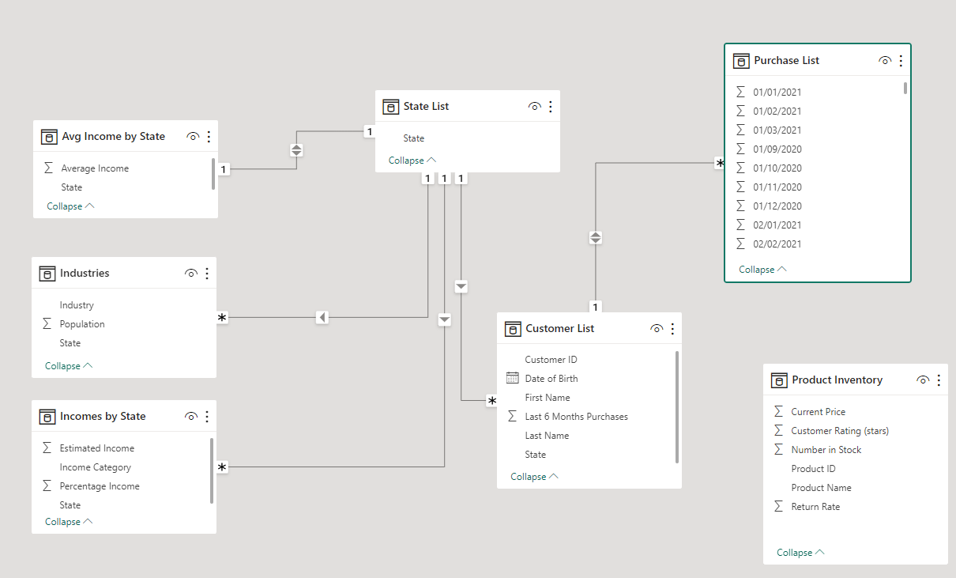

‘Product Inventory’ table in Power Query

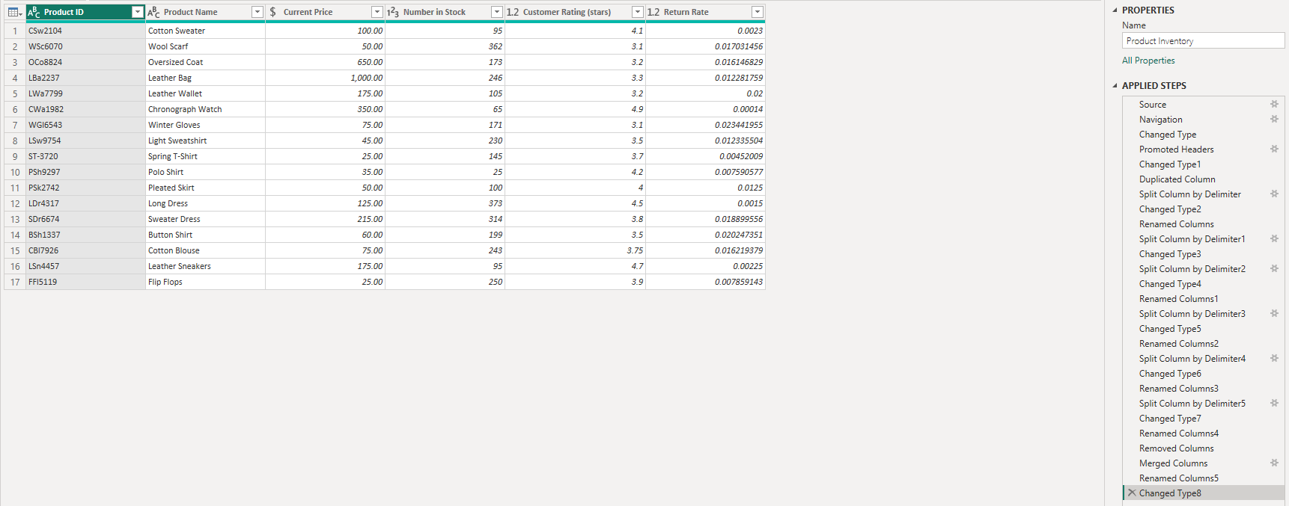

‘Purchase List’ table in Power Query

